Pics in different search engines.
There are many search engines that allow people to find information in a quite short time without any difficulties. It may seem that mechanism of engine works perfectly, however, searching of necessary images can still be not so easy. Most services have some disadvantages, so not every user can find necessary material. However, we know how to solve your problems or make them easier. And there are seven tips how to use different systems to get the definite result:
- Virtually, all the people on the Earth know such a popular engine as Google. It has really useful search tools that help to specify each point of your search. To avoid low-quality results, you can choose minimum size of image or even write your precise one. Type of file, color of the picture, time of uploading, and all these points are there to help you. Also, you can use SafeSearch to filter explicit results. To see the size of the picture in the preview, you should choose ‘more tools’ and then ‘show sizes’, so, you are able to see it in left lower corner of each picture.
- If you have poor quality of the image and you want to find bigger or better one, the icon of camera in the search engine will help you like no one else! All you need is to click on it and upload the picture or paste its URL.
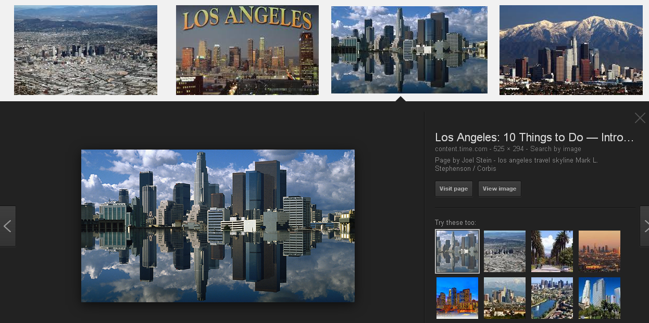
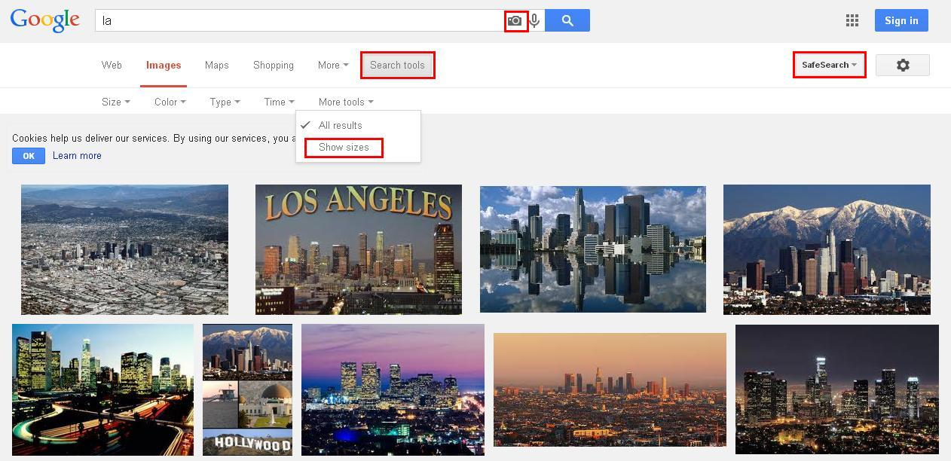
- If you want to find similar pictures or information about them, just click on the photo and there appears a link of the website where you can discover all the necessary information and similar files. Moreover you can choose the option ‘view image’ to see its full size and download it.
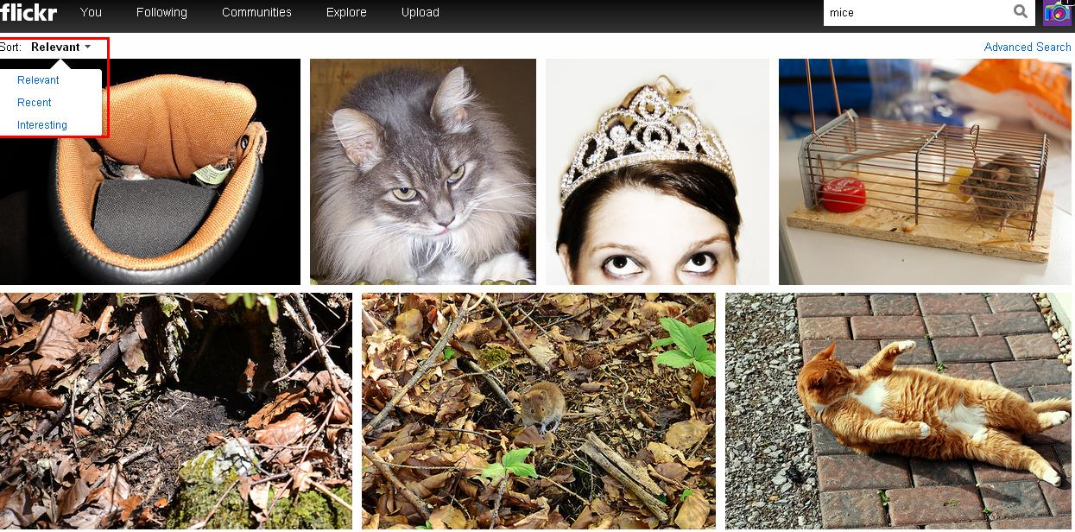
- One more comfortable and efficient system to find the images is Flickr, which provides you with high quality and easy mechanism of searching. You can sort the photos by relevance and other options.
- Use Tumblr if you want to find the most recent or the most popular files which are referred to the necessary theme. It’s possible to sort all the images in a proper way for you.

On the top of the page you’ll find blogs that have necessary for you content. Sometimes you can come across the official blog of magazine/person/organization. So, you can just follow it and check this page from time to time.
- If you use Yandex, it’s possible to choose even the website where the pictures are to be found. You just should paste the link, type your request and the search engine will show you all the results. The column ‘size’ differs from the same one in Google but it’s not less efficient. There you can find specially selected pictures for your computer or notebook. However, it’s also possible to choose the shape of the photo, so you can set it as wallpaper for different devices. By the way, nowadays majority of them have search engine apps, so it’s easier for you to find information at a definite time with your device.
- So, remember one rule: don’t forget to use hashtags! They make the search much easier and save your time!

